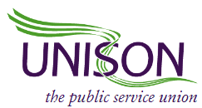

REGIONAL WOMEN’S COMMITTEE TRAINING DAY
9:30AM- 6:00PM
Friday 13th March 2020

UNISON CENTRE

2020: AGENDA

09:30am: | REGISTRATION
10:00am: | Welcome introductions (RMT women’s committee chair)
10:10am: | Opening Remarks Christine McAnea
10:40am: | Workshop - Writing a motion Maggi Ferncombe
11:30am: | BREAK
11:45am:  12.45PM | Women’s Trust session- Heidi Reidel  Settled Status session-Katia Widlak
1.15pm: | LUNCH
2:00pm:  2.20pm | National Women’s Officers Report- Josie Irwin  Menopause workshop LAOS
3:20pm: | BREAK
3:30pm: | Comedian- Her and ‘The change in me’ Debbie Baisden
4:45pm: | Closing remarks –Succession planning/Evaluation forms Myra Wale

Drinks and nibbles will be served from 5pm

6:00pm Raffle

