Henry Garrido
Executive Director, District Council 37
AFSCME
125 Barclay Street
New York
NY10001

8th June 2020

RE - Solidarity Message from UNISON Greater London

Dear Henry

We wanted to write to you on behalf of all UNISON members in London to pass on our solidarity to you and your members in AFSCME DC 37 during these difficult times. We too are the largest union in our city and as the public services union, have borne the brunt of dealing with Covid 19. The heroic efforts of your members in either battling Covid 19 on the frontline or ensuring the necessary infrastructure of New York continues running for its residents is remarkable.

Like us, you will have lost too many members to this wretched virus and we ask that you please accept our condolences on behalf of their friends, union comrades and of course their families.

Like you, we are still struggling to deal, day to day, with the virus under a government either too inept, too ignorant or simply incapable of recognising the daily struggle our members and city residents face. All while restrictions are being lifted too soon and like you we live in the very real fear of a second wave and the pressure this would put on already overburdened and historically underfunded public services.

Please know that if there is any support we can provide, even if it is just friendship and solidarity, you only have to ask.

Similarly, we stand shoulder to shoulder with you on challenging systemic racism ingrained in our societies. We have been inspired by the level of activism that your city has shown and we too will encourage our members to get involved in the movement to eradicate racism.

We believe that now is the time for long due change and whilst we, in our respective unions, have been fighting against racism, discrimination and racist values for some time, it now feels that, finally, society is ready to listen. The next few months will be difficult and painful however we believe there is finally hope.

We look forward to a time when we can correspond in better circumstances

Yours in friendship
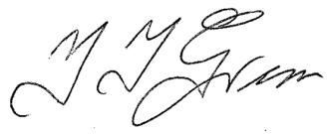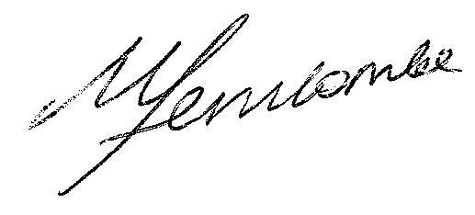
Yvonne Greene Maggi Ferncombe
Regional Convenor Regional Secretary
UNISON - Greater London UNISON - Greater London

